
FRIENDS SCHOOL KAMUSINGA

233/1
CHEMISTRY
FORM 4 INTERNAL MOCK 2026
TIME: 2HOURS
CHEMISTRY
PAPER 1
(THEORY)
@2026

ADM NO

NAME

4

SIGN

FORM

INSTRUCTIONS TO CANDIDATES:

Instructions To Candidates
- Sign and write the date of the examination in the spaces provided above.
- Answer All questions in the spaces provided in the question paper.
- Non – programmable silent electronic calculators and KNEC mathematical tables may be used
- Workings must clearly show where necessary.
- Candidate should check the questions paper to ascertain that all the pages are printed as indicated that no questions are missing.
- candidates should answer the questions in English.

For Examiner’s Use Only

Questions | Maximum score | Student’s score
1 – 29 | 80

Answer all questions in this paper in the spaces provided
- Figure 1 below shows an experiment used to determine the proportion of air used in combustion
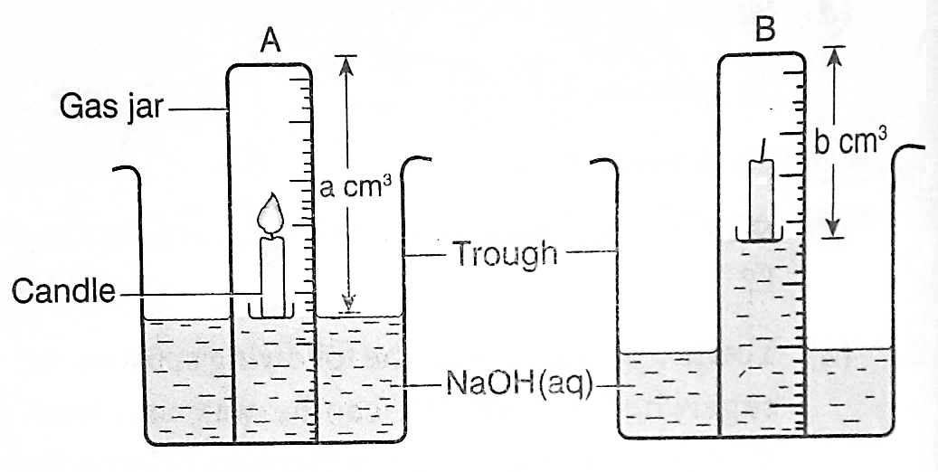

  - Why was NaOH _{(aq)} used instead of water? (1 mark)

  - Using the set up in Figure 1, describe how the proportion of air (%) used up during combustion can be calculated. (2 marks)

  - Identify one source of inaccuracy in results in the experiment above. (1 mark)

- The empirical formular of an organic compound is C₂H₂. When 10.4g of the substance were allowed to evaporate, it occupied 4800 cm³ at r.t.p. Determine the molecular formula of the compound. (C=12.0,H=1.0, molar gas volume at r.t.p = 24 dm³).
(2 marks)

- (a) When a current of 0.6 A was passed through a molten salt of metal C for 1 ½ hours 3.79g of C were deposited. Determine the charge on metal C. (C=226, 1F=96500C)
(2 marks)

- Identify the products at the anode when;
  - Concentrated NaCl solution is electrolyzed. (1 mark)

  - Dilute NaCl is electrolyzed. (1 mark)

- Sulphur (IV) Oxide has many uses .complete the table below by indicating the role played by sulphur (IV) Oxide in the following. (2mrks)
Area of Use | Role of sulphur(IV) oxide
Grain silos
Fruit and food processing
- Sulphuric acid is used in metallurgical industries to clean steel before it is galvanized. Explain the role of sulphuric acid. (1mrk)

- The set up in Figure 2 below shows preparation of ammonia gas by a student.
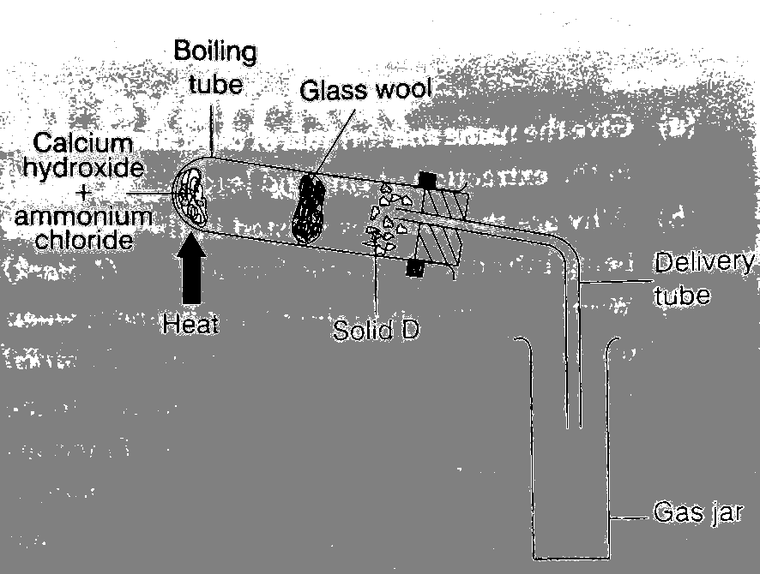

Figure 2

  - Identify solid D and state its role
Identity ……………………………………………………. (½ mark)

Role ……………………………………………………. (½ mark)

  - State one mistake in the set up in Figure 2 above. (1 mark)

  - Write an equation for the reaction that occurs in the boiling tube. (1 mark)

- The figure below shows how Chlorine gas is bubbled through potassium bromide. Study it and answer the questions that follow.

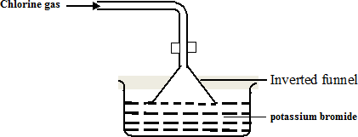

State and Explain the observation made in beaker. (2mrks)

- Carbon (II) oxide gas and steam are produced according to the equilibrium below.

2CH_{4(g)} + 3O_{2(g)} 2CO_{(g)} + 4H₂O_{(g)} , ΔH = -ve

Explain how the yield of the products in the above reaction is affected by:
  - Increase in temperature. (1½ marks)

  - Lowering pressure. (1½ marks)

- The structures below are a representation of cleansing agents M and N.
R  OSO⁻ Na⁺ R - COO⁻Na⁺
3
M N
(i) Identify the agents. (1 mark) M…………………………………………………N....................................................
- Explain why agent M causes water pollution. (1mark)

- Tetraoxophosphate is usually added to remove Ca²⁺ and Mg²⁺ during cleaning and provides nutrients for aquatic plants. The plants grow quickly depleting the dissolved oxygen. Name the process described. (1mark)

- Ethane reacts with bromine according to the equation below.

C₂H_{6(g)} + Br_{2(g)} C₂H₅Br_{(g)} + HBr_{(g)}

Using the bond energies in the table below calculate the energy change for the reaction that occurs.
Bond | C – H | C – Br | Br – Br | H – Br | C – C
Bond energy | 413 | 280 | 193 | 365 | 3 46

(3 marks)

- a) Name the major raw material from which Aluminium is extracted. (1mark)

(b) Explain why cryolite is added to aluminium oxide before electrolysis. (1 mark)

- Explain why Aluminium is extracted using electrolysis. (1mark)

- An unknown, colourless solution G has the following properties;
- Turns blue litmus paper red
- Reacts with a clean magnesium ribbon to produce a gas which extinguishes a burning splint with a ‘pop’ sound
- Reacts with sodium carbonate powder to form a colourless gas which forms a white precipitate with calcium hydroxide solution
- When warmed with an oxide of copper, a blue solution is formed
- On addition of Barium nitrate, a white precipitate is produced
  - What do properties (i) and (ii) indicate about solution G? (1 mark)

  - Write the formular for the;
    - Blue solution. (½ mark)

    - Oxide of copper. (½ mark)

(c)Write an ionic equation for property (v). (1 mark)

- (a) Define the term half-life. (1 mark)

(b)A certain nuclide has a half-life of 2.5 hours. What percentage of a given mass of the nuclide will be left after 7.5 hrs? (2 marks)

- Study the overall equation for an electrochemical cell shown below;
H2+ (aq) + J(s) J2+ (aq) + H (s)
Which species undergoes oxidation? Explain (1 mark)

- (a) Name the subatomic particle that has no charge and state where it is located in the atom.
(1 mark)

(b)An ion of element K has the formula $\begin{matrix}10 \\ 5\end{matrix}$ K³⁺

- Write the electronic configuration of the ion. (1 mark)

- Draw the structure of the ion of K. (1 mark)

    - Write the formula of the oxide of K. (1 mark)

- Electroplating refers to the process of coating a reactive metal with a layer of less reactive.
- Give ONE reason for electroplating. (1mrk)

- During Electroplating of iron spoon with copper the type of electrolyte that should be used is copper (ii) sulphate solution. Write the equation for the reaction at the cathode. (1mrk)

- The following diagrams show the structure of two allotropes of carbon. Study them and answer the questions that follow.
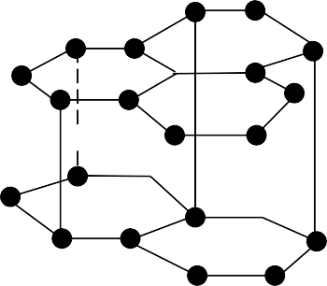



A B

  - Name the allotropes. (1 mark)
A……………………………………………………B…………………………………………
  - Which allotrope conducts electricity? Explain. (2 marks)

- Fluorine, Chlorine and Bromine has the boiling point of -188 , -35 and 59 Explain the trend in the boiling points. (2mrks)

- Describe how solutions containing Zn²⁺ and Al³⁺ ions can be distinguished in the laboratory. (3 marks)

- Ten grams of calcium nitrate were completely decomposed on heating according to the reaction.
2Ca (NO3 ) → 2CaO(s) + 4NO2( g ) + O2 (g)
2(s)
- Determine the mass of the residue CaO that was left. (Ca=40, N=14, O=16)
(2 marks)

- How many ions does 0.1 mole of calcium nitrate solution contain(𝐿 = 6.0 × 10²³)
(1 mark)

- The table below gives the solubilities of Sodium Bromine and Sodium Sulphate at 20ºC and at 60ºC;
Substance | Solubility in g/100g of water
Substance | 20ºC | 60ºC
Sodium Bromide | 55 | 75
Sodium Sulphate | 10 | 12
When aqueous mixture containing 60g of NaBr and 7g of Na₂SO4 in 100g water at 80ºC was cooled to 20ºC, some crystals were formed;

- Identify the crystals. (1 mark)
(ii)Determine the mass of the crystals formed. (1 mark)

(iii)Name the method used to obtain the crystals. (1 mark)

- Given below are molar enthalpies of combustion of propane, hydrogen and carbon.
C₂H_{8(g) +} 5O_{2(g)} 3CO_{2(g)} + 4H₂O_{(l)} ; ΔH = -2220 kJ/ mole

H_{2(g)} + ½O_{2(g)} H₂O ΔH=-286kJ/mole

C_{(s)} + O_{2(g)} CO_{2(g)} ΔH = -393 KJ/mole

Use the above information to calculate the molar enthalpy of formation of propane.(3 marks)

- Magnesium is hard to cut with a knife however it is Ductile and Malleable while calcium is brittle hence cannot be cut with a knife. Define.
(i)Ductile. (1mrk)

(ii)Some metals produces sound when strucked, Name the property described. (1mrk)

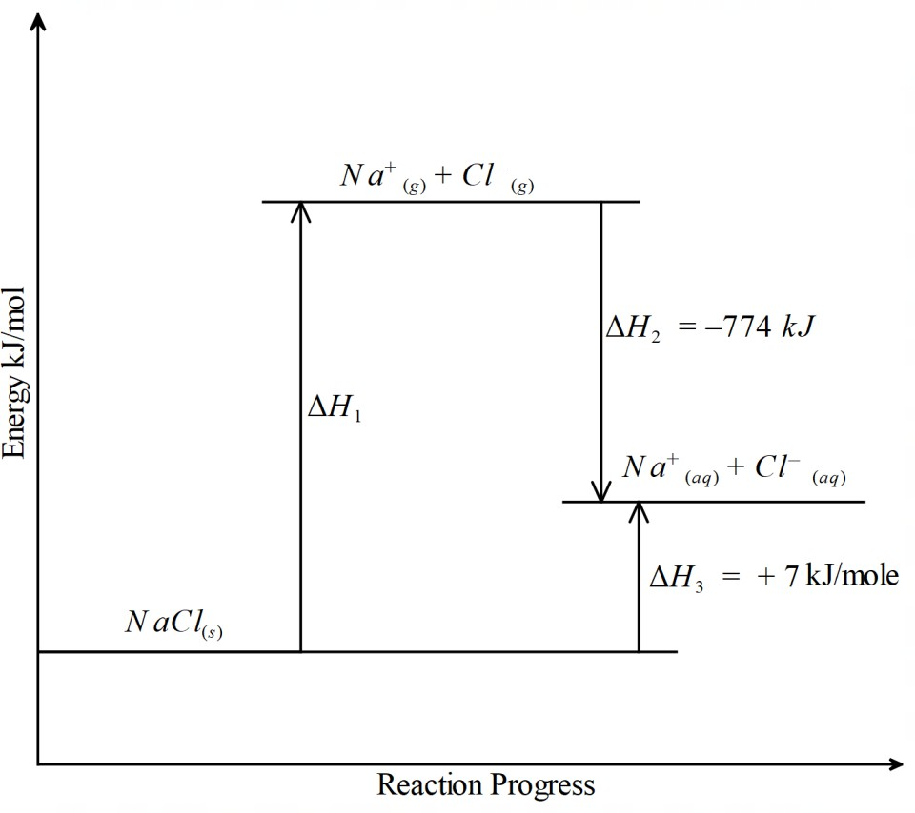
- The diagram below shows energy changes in a reaction. Use it to answer the questions that follow.
  - What is the name given to ΔH₃ (1 mark)

  - Calculate the value for ΔH₁ (1 mark)

  - State one factor that determines the amount of hydration energy. (1 mark)

- (i)Give the name of the third member of the alkyne homologous series (1mrk)

ii) Describe a chemical test that can be used to distinguish between propane and Prop-1-yne. (2marks)

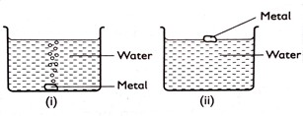
- Some metals were reacted with cold water. Hydrogen gas is given off. The diagram below shows reactions of the metals.
(a)Predict the metals in set-up (i) and (ii) (1mrk)

(b)Write equation for the reaction taking place in set –up (i) (1mrk)

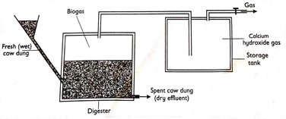
- When manure rots in tanks called digester , biogas which is a mixture of 60% methane and 40% carbon (IV) Oxide is formed .Biogas is used as a fuel.

  - Explain how calcium hydroxide in the gas storage improve the fuel . (1mark)

  - State one disadvantage of using biogas as a fuel. (1mark)

  - Give one use of the Dry effluent. (1mark)

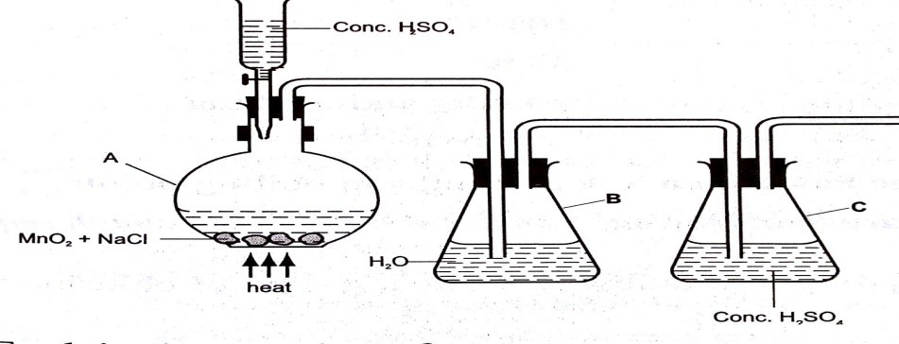
- Chlorine can be prepared by Oxidation of chloride ions by oxidizing agents as shown in the diagram below.
Explain the function of the following.
(i)Concentrated sulphuric(VI) Acid in the reaction vessel A . (1mark)

(ii)Water in container B. (1mark)

(iii)Complete the set-up to show how dry chlorine gas is collected. (1mark)
- i)State Boyles law. (1mark)

ii) A gas occupies 4dm³ at a pressure of 152mmHg. Calculate the gas pressure when the volumes are reduced to 1.5dm³. (2marks)

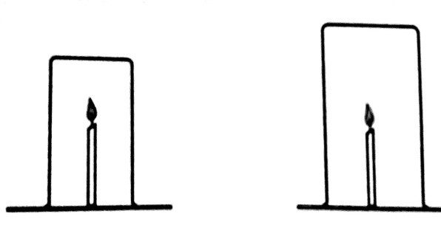
  - A burning candle was covered with beakers of different sizes. The time taken for the candle to go off in the different beakers was recorded.
  - Explain why the same kind of candles be used in all the experiments. (1mark)

  - Explain why the candle takes longer to go off in the larger beaker . (1mark)

  - The experiment was repeated with a shorter candle. The time recorded for the candle to go off was longer than in the first experiment. Explain the observation. (1mark)

- The diagram below shows a cell made up of the half-cells of elements R and T.
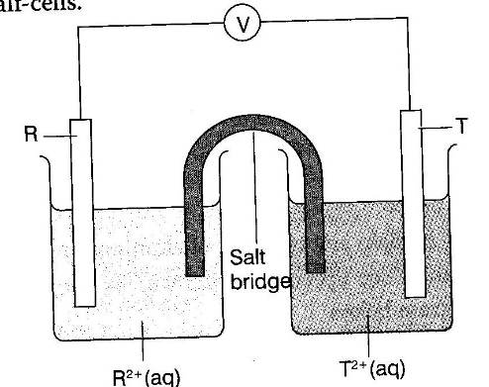
Given that the electrode potential for the above cell is +3.22V and the standard electrode potential of the half-cell R is -2.38V.
  - Write a cell diagram for the above electrochemical cell. (1 mark)
  - Calculate the E^{θ} of electrode T. (1mark)

  - Which is a stronger oxidizing agent. (1 mark)

